RPA AA360 Bot Operations Runbook – Off-Cycle Manual Paysheet

Title: Bot Operations Runbook – Off-Cycle Manual Paysheet
Version: BOR_OFCMP_V1.0
Date: 11-19-2025
Owner: Carolyn Otmar
Approvers:

Use Case Name: Off-Cycle Manual Paysheet
Business Unit: Production
Priority:
Environments Covered: <DEV | UAT | PROD>

1) Run-at-a-Glance

- Run Window: 6:00 AM to 8:00 AM PT
- Trigger: Scheduled every weekday at 6:00 AM
- Average Duration for Bot: Avg 50 minutes for 150 Transactions
- Average Duration for Business User: 20 minutes for 1 Transactions

- Expected Volume: 200 processes/month
- Inputs: Excel “Manual Entries” workbook from Box; Pay Group; PPED
- Outputs: Paysheets in PeopleSoft; Action Log; Exception Log; Post Run Report, Validation Report Post-Run Email

Green Path:
1. Bot Downloads Manual Entries Excel workbook from BOX through API.
2. Extracts Company / Pay Group / Pay Period End Date and line items.
3. Logs into PeopleSoft, finds the highest off-cycle page and adds +1 (bot uses 9000-page range).
4. Creates Paysheet (By Paysheet) with Off-Cycle checked.
5. Populates Earnings rows from Excel; saves.
6. Writes OutputReports/Action/Exception Logs to controlled storage.
7. Sends summary email with Attachments of outputs.

2) Contacts & RACI

Role | Name | Contact | Responsibilities
Process Owner | Carolyn Otmar | carolyn.otmar@ucop.edu | Business decisions, SLA sign-off
Run Operator (L1) | <ENTER> | <ENTER> | Monitor runs, basic triage
Support (L2) | <ENTER> | <ENTER> | Bot fixes, config, reruns
Platform Admin (AA360) | <ENTER> | <ENTER> | Runners, creds, HA/DR
App Owner – PeopleSoft | <ENTER> | <ENTER> | Access, downtime comms
Storage Owner – Box | <ENTER> | <ENTER> | Folders, permissions

RACI Matrix (key operations)
Responsible (R), Accountable (A), Consulted (C), and Informed (I)
Activity | Run Operator | L2 Support | Platform Admin | Process Owner | App Owners
Scheduling | R | C | A | I | I
Credential Mgmt | I | C | A | I | I
Run Execution | R | A | C | I | I
Incident Mgmt | R | A | C | C | C
Change Mgmt | I | C | C | A | C

3) System Architecture (high-level)

Components: AA360 Control Room, Bot Runners, Box, Excel files, PeopleSoft, Email (SMTP),
Network/Firewall: (e.g., Allow outbound to Box/PeopleSoft; CR/Runners mutual reachability).
Proxy/MFA: API for Box, Using Native PeopleSoft via service account; conditional access exceptions as approved.

4) Environments & URLs

ENV | Control Room URL | App URLs | API Base URLs | Runners | Notes
DEV | https://ucopdev.my.automationanywhere.digital/ | https://ucphrdev.ps.universityofcalifornia.edu/psp/ucphrdev/EMPLOYEE/HRMS/ | N/A | <ENTER> | <ENTER>
UAT | https://ucopdev.my.automationanywhere.digital/ | *PeopleSoft UAT; Box UAT* | <ENTER> | <ENTER> | <ENTER>
PROD | https://ucop.my.automationanywhere.digital/ | *PeopleSoft PROD; Box PROD* | <ENTER> | <ENTER> | <ENTER>

5) Schedules, Triggers & Calendars

ENV | Schedule/CRON | Timezone | Skip/Holiday Rules | Dependencies (jobs/windows)
PROD | Scheduled every weekday at 6:00 AM | PT | <ENTER>

**Event-based triggers (optional):** <Folder watcher | Webhook | Queue WLM> — <ENTER DETAILS>.

6) Inputs, Outputs

- Location: \Box\RPA_POC\PROD\Offcycle Manual Paysheet\Production File Drop\ OFCMP_MMDDYYYY.xlsx
- File Patterns: OFCMP_MMDDYYYY.xlsx
- Schema (example):
INPUTS
Column | Type | Required | Example
Company | string | ✓ | *UCS / LBNL1 → LBL*
PGRP (Pay Group) | string | ✓ | *NB7*
Pay Period End Date (PPED) | date | ✓ | *2025-08-02*
EID (Employee ID) | string | ✓ | *12345678*
ER (Employee Record) | int | ✓ | *0 / 1*
ECD (Earnings Code) | string | ✓ | *REG / OTP*
Hours | number | ✓ | *40*
BEGDATE (Earnings Begin Date) | date | ✓ | *2025-06-09*
ENDDATE (Earnings End Date) | date | ✓ | *2025-06-13*
Amount | number | ✓ | *250.00 / 12.50*
Hourly Rate | number | ✓ | *15.00*
Page Number | number | ✓ | 9001

OUTPUTS
- Paysheets Output Report
- Action Log
- Exception Log
- Post-Run Email: Summary, links to logs & outputs.

7) Credentials & Locker (AA360)

Purpose | Locker | Credential Name | Access Level | Rotation | Owner | AA Role
Box Secret | UCPATH | UCP-PRODUCTION-BOX | Consumer | <ENTER> | Locker Admin | Create Role to access specific UCPATH folder
PeopleSoft | UCPATH | UCP-PRODUCTION-OFFCYCLE-PSFT | Consumer | <ENTER> | Locker Admin | Create Role to access specific UCPATH folder

8) Configuration, Parameters, Global Values

- Config Store: <XML>/<JSON>
- Run ID pattern (recommended): `<USECASE>_<ENV>_<YYYYMMDDHHMMSS>` (e.g., OCMP_DEV_202509252151146)
Global Variables:
Key | Value | ENV Overrides | Description
EmailSMTPHost | ucpath-smtp-prod-6944b56a029cc8b8.elb.us-west-2.amazonaws.com | DEV/UAT/PROD | SMTP Host will be used across all automations to send email from the bot
SMTPPort | 587 | DEV/UAT/PROD | SMTP Port will be used across all automations to send email from the bot
UCPathFromEmail | UCPC-IT-RPA@ucop.edu | DEV/UAT/PROD | This will be the email Bot will send emails through

9) Bot Package Information

Type | Name | Path | Comments
Task Bot | OffCycleManualPaysheet | Bots\UCPath\Production\Off Cycle Manual Paysheet | This task needs to be used for scheduling
Text | Config.xml | Bots\UCPath\Production\Off Cycle Manual Paysheet
Task Bot | 1.0_Main | Bots\UCPath\Production\Off Cycle Manual Paysheet
Task Bot | 1.1_Read_Config | Bots\UCPath\Production\Off Cycle Manual Paysheet
Task Bot | 2.0_init | Bots\UCPath\Production\Off Cycle Manual Paysheet
Task Bot | 2.1_Kill_Task | Bots\UCPath\Production\Off Cycle Manual Paysheet
Task Bot | 2.2.2_LogArchive | Bots\UCPath\Production\Off Cycle Manual Paysheet
Task Bot | 2.3.0_Initialize | Bots\UCPath\Production\Off Cycle Manual Paysheet
Task Bot | 2.3.1_BoxDownload | Bots\UCPath\Production\Off Cycle Manual Paysheet
Task Bot | 2.3.1_BoxUpload | Bots\UCPath\Production\Off Cycle Manual Paysheet
Task Bot | 3.0_GetTransaction | Bots\UCPath\Production\Off Cycle Manual Paysheet
Task Bot | 4.0_ProcessTransaction | Bots\UCPath\Production\Off Cycle Manual Paysheet
Task Bot | 5.0_Exception_Manager | Bots\UCPath\Production\Off Cycle Manual Paysheet
Task Bot | 6.0_Logger | Bots\UCPath\Production\Off Cycle Manual Paysheet
Task Bot | 7.0_GenerateReports | Bots\UCPath\Production\Off Cycle Manual Paysheet
Task Bot | 8.0_EmailManager | Bots\UCPath\Production\Off Cycle Manual Paysheet

9) Dependencies

- Upstream: Manual entries workbook availability; PeopleSoft pages Query, Pay Period End Dates.
- Highest Page Number Query in PeopleSoft: UC_PY216_OFFCYLE_PAGE_NUM_LINE
- Downstream: Payroll processing using created paysheets.
- Maintenance/Blackouts: PeopleSoft patch windows; Box outages.
- Pre-reqs: service accounts active; page range Query available, Box folder access.

10) Pre-Run Checklist (operator)

- [ ] Control Room healthy (**status link**).
- [ ] Runner(s) online; Bot Package = `<ENTER VERSION>`.
- [ ] Lockers accessible; credentials valid (no imminent expiry).
- [ ] Box Package installed.
- [ ] Box PPE folder reachable; expected file(s) present/valid.
- [ ] PeopleSoft available; **off-cycle pages in Calculated**.
- [ ] Capacity headroom Bot runner
- [ ] No change freeze/blackout in effect.
- [ ] Server Name to schedule the bot in Production control room
- [ ] Enable in Google Chrome: Ask where to save each file before downloading

11) Standard Run Procedure

1. **Navigate:** CR → Bots → `<Folder/Task>` → **Run**.
2. **Parameters:** `ENV=<ENTER>`, `DateRange=<ENTER>`, `DryRun=<true/false>`.
3. **Milestones (expected logs):**
- `INGEST_START/END` (Box → Excel)
- `PS_VALIDATE_PAGE` (highest page; +1 applied)
- `PS_CREATE` (By Paysheet)
- `PS_POPULATE` (earnings rows)
- `SUMMARY_SENT` (email)
4. **Completion validation:** Paysheets exist; counts match; logs archived.
5. **Post-run:** Archive input; persist Action/Exception Logs; send summary.

12) Logging & Observability

- Run ID: Include in all logs, artifacts, emails, and file names.
- Log fields: Action Logs, Exception Logs
- Locations: Box

13) Monitoring & Alerts

- Monitored: Control Room
- Alert Channels: Email

**Email Template**
- **Subject:** `[<ENTITY>][<ENV>] <USECASE> RUNID <RUN_ID>`
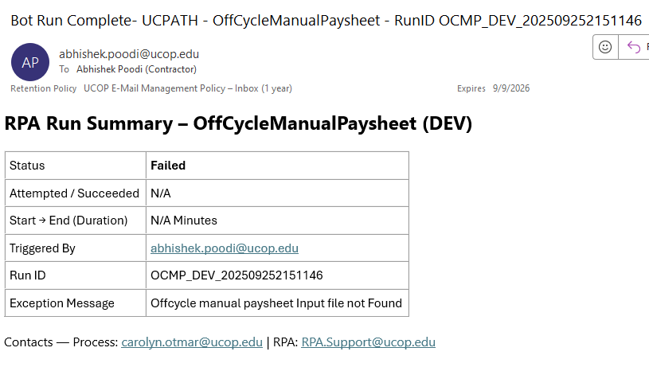

14) Maintenance & Change Management

- **Patch windows:** <ENTER>
- **Package upgrades/deps:** Versioned; rollback plan documented.
- **Change requests:** Template + approvals before PROD.

15) Testing & Validation

- **Pre-prod gates:** Access checks; smoke tests; sample PPE data.
- **Test data mgmt:** Synthetic rows for edge cases (missing ER, invalid PPED).
- **UAT sign-off:** <ENTER>
- **Post-deployment checklist:** Run on window; verify email summary; audit logs populated.

16) Appendix

**Links (dashboards, CR folders, repo, SOPs, PDD):**
- Process Design Document – *Off-Cycle Manual Paysheet*
- Control Room Folder: `<ENTER>`
- Run Dashboard: `<ENTER>`
- SOP – Manual Fallback: `<ENTER>`

**Change Log**

Date | Version | Change | By
<ENTER> | <ENTER> | Initial release | <ENTER>

